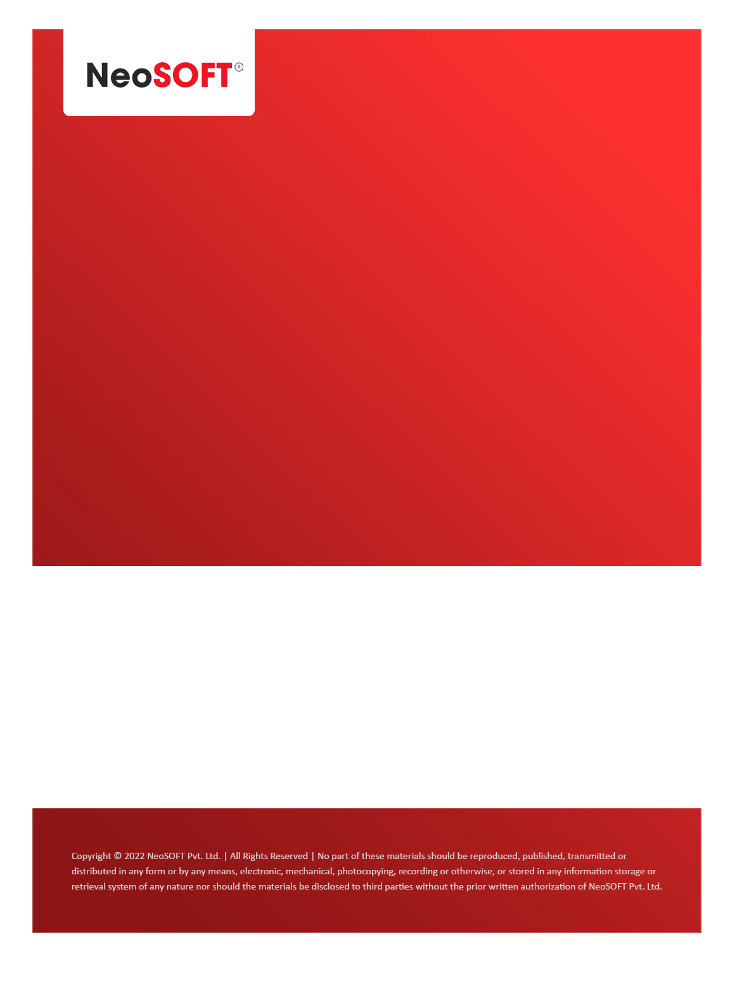`

**Eltizam**

**MOM – RGM 3**

Eltizam

Client Name

NeoSOFT is a SEI-CMMI Level-5 Global IT Consulting & Software Solutions Provider

**March 20**, 2023

|  |  |
| --- | --- |
| **Meeting Date, Time, and Attendee Details** | |
| **Date** | 20th March 2023 |
| **Venue** | MS Teams |
| **Time** | 05.30 PM – 07.00 PM IST |
| **Meeting Type** | Requirements Gathering Session |
| **Internal Attendees** | * YallaReddy * Akshata Shinde |
| **Client Attendees** | * Karuna Pawar |
| **MOM Prepared By** | * Karuna Pawar * Akshata Shinde |

|  |  |
| --- | --- |
| **Details of Meeting** | |
| **Sr. No.** | **Description** |
| 1 | We started discussing initial requirements as session-3. |
| 2 | Discussed application master details with team, below are the modules which we covered   * Location module * Valuation Request -- Valuation Request from external parties |
| 3 | Depends on availability of Vinod, we will review the till now progress with team. Karuna will confirm the dates |
| 4 | Akshata, will be continue working on discussed points & put them into functionality document, top level wireframe for next call. |
| 5 | Eltizam, Client is expecting us to share some real estate related developed projects inforation from NeoSOFT & Poonam needs to share portals. |
| 6 | We need to share testing methodologies for project. Will it be fully manual or we involve any automation? This we will discuss in the coming weeks is not a high priority for now. |
| 7 | We need to share NeoSOFT coding standard plans/approaches for both UI, backend with Eltizam before coding starts. This is not a show stopper now. |

|  |  |  |  |  |  |
| --- | --- | --- | --- | --- | --- |
| **Actionable** | | | | | |
| **Sr. No.** | **Action Item** | **Assigned to** | **Assigned Date** | **Expected Completion Date** | **Status** |
| 1 | Poonam needs to come with NeoSOFT pre-existing project which client asked in Kick-off meeting | Poonam Lalka | Mar 13 |  |  |
|  |  |  |  |  |  |
|  |  |  |  |  |  |
|  |  |  |  |  |  |